**User Manual For TheDataReader:**

# Introduction:

Welcome to TheDataReader’s user manual. This manual covers the features of the program and gives an outline of how to use it. With the screenshots of the application, we'll walk you through the functionalities of this data app.

## Starting:

The files required for running this application are ‘display.py’, ‘calendar_dec18_piechart.py’, ‘cleanliness.py’, and ‘display_screen_logic.py’. The application requires at least python version 3.7 to run, along with the following imports: tkinter, pandas, plotly[.express], Image, io, pythonwx, datetime and matplotlib.

After installing the application files and appropriately installing the imports, double click ‘display_screen_logic.py’ and it to launch it.

## Starting Screen:

The first screen is an introduction to the application and is one of the easiest to get through and use.

Selecting a File: To start, click the "Select" button. This will open a file dialog, allowing you to choose a CSV file from your computer.

Select File Dialog: Navigate to the directory where your CSV file is located, select it, and click "Open." The chosen file will be displayed on the next screen.

## Display Screen:

The display screen offers an options nav-menu, linking to both the Rentals Graph and the Cleanliness Graph, each opening a new window for their respective functions. The primary focus of this window, however, is the search engine and the visualization capabilities.

The main portion of the window is an interactive data grid in which you may copy any given cell, row, or column by left-clicking and pressing ctrl-C (windows).

The left most text field serves as the search bar. To search for any particular word in the csv file, the user must enter the word in the text field and click the search button. The program searches the csv file for any matches, collects them, and outputs them onto the grid, therefore replacing whatever was last in the grid.

This search can be further enhanced by adding a date period for the search. The two text fields right of the search button serve as date fields (left most box as the lower limit and right most box as the upper limit). To search using a date period, the user must input their search term in the search field, oldest date in the next field and the latest date period in the final period (both using the format yyyy-mm-dd) before left-clicking the search button.

To set the grid back to displaying all the csv data, the user must left click the search button without anything in the search field or date fields.

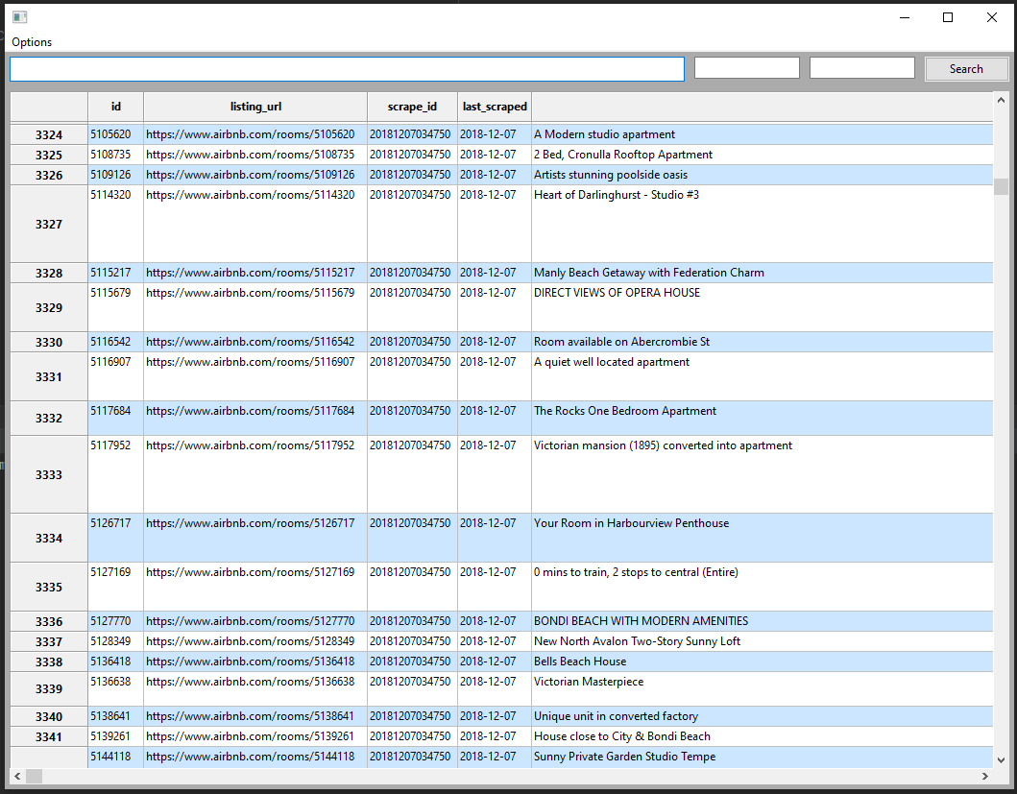

## Rentals Graph Screen:

On selecting the Rentals Graph button, the user is greeted with the same screen as initially opening the program. The user must navigate and select a csv file using the file dialog. This file is analyzed by the program and outputs a pie graph in a new window.

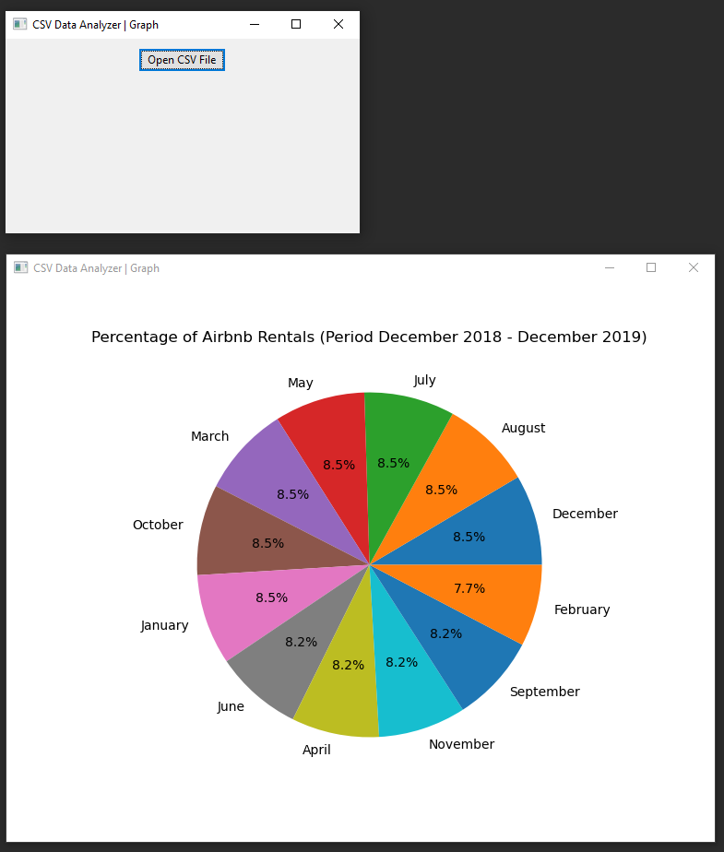

## Rentals Graph Screen:

On selecting the Cleanliness Graph button, the data relating to cleanliness is analyzed by the program and outputs a pie graph in a new window. This works similarly to the Rentals Graph, however, this display uses a pre-loaded, relative csv file and does not allow for the user to input a custom csv file.